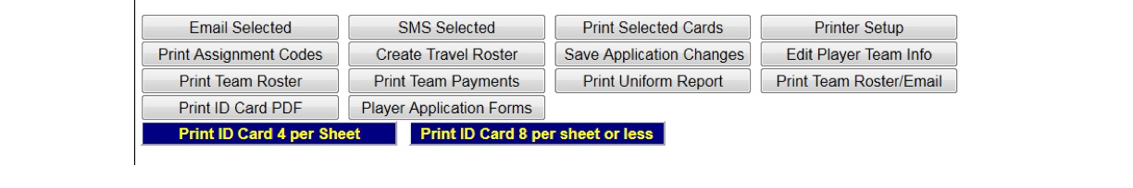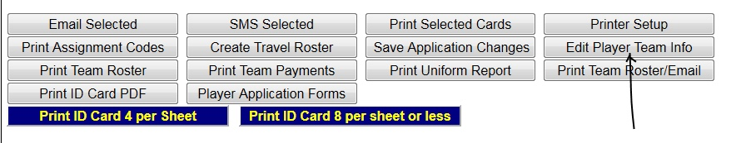Adding Uniform Numbers:
Jersey numbers must be added to the roster before we print game cards.
This must be completed by the league Registrar. To add player jersey numbers to
the game roster/ sheets, please follow these instructions:
• Log-in with your username and password.
• Select the team you wish to enter the jersey numbers for.
• Scroll down and click on “edit player info” put in the jersey numbers and
click on “save changes.”
• Both Home and Away columns should be completed with the same jersey
number. If you do not place jersey number is both columns it will not print
on the game card. Step 1
Click on the team you wish to add jersey number to. Step 2
Scroll down to the bottom of the team roster you selected.

Click on “Edit Player Team Info”

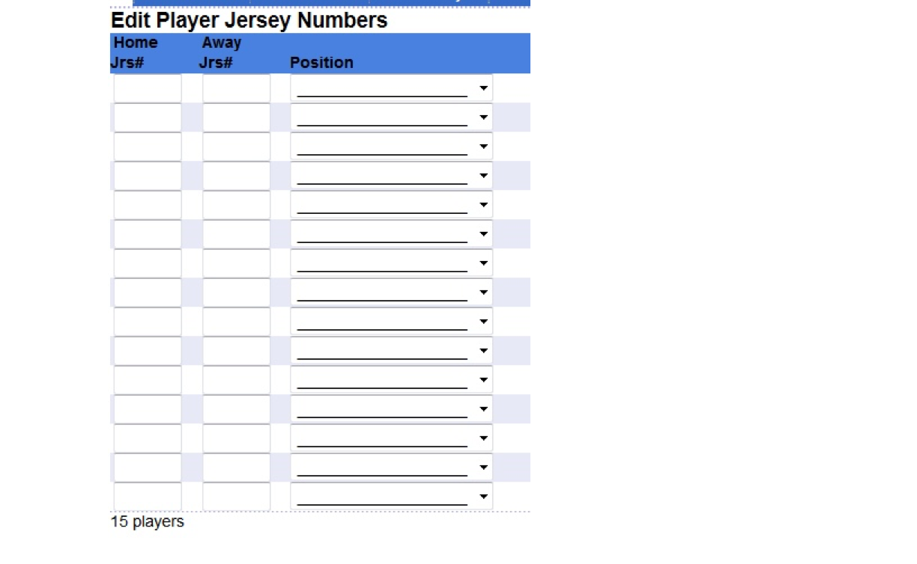The next page will look like this:

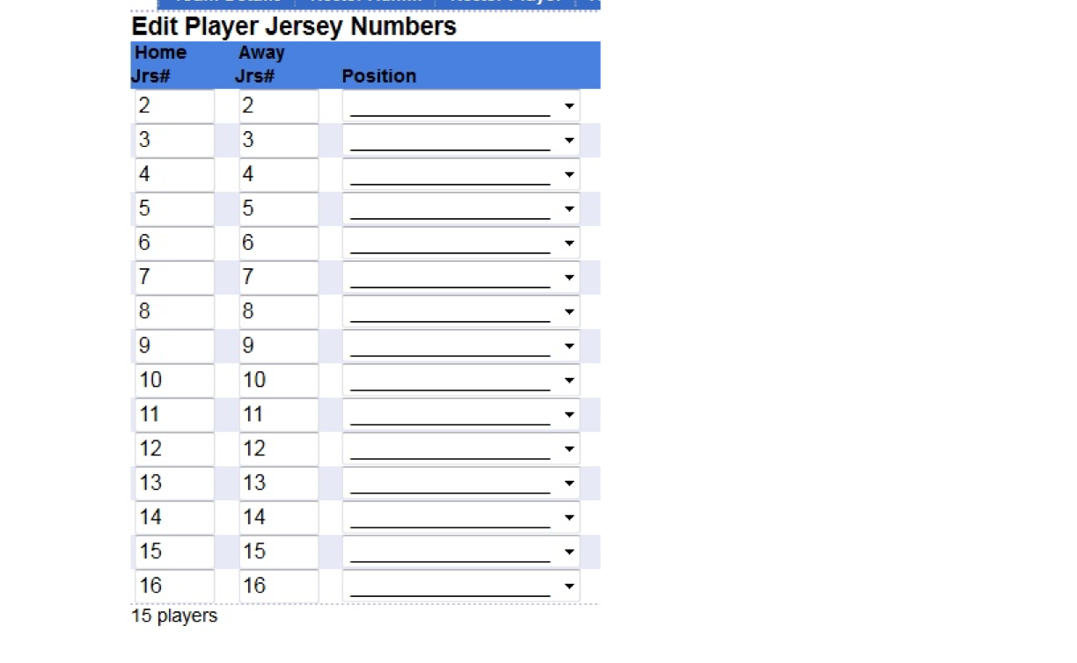Step 3
In the Home and Away columns, put each players jersey number. Have you have inputted the jersey numbers, it should look like this.

Make sure you click on “Save Changes” before you exit out of that screen.

You have entered all the jersey numbers, they will show on the game cards when we print for the

