Player Jersey Numbers

Coaches/League Registrar can log in to their account and add jersey numbers to their players. These jersey numbers will appear on standard rosters printed with the system. To update jersey numbers, please follow the steps below.
1. Log in to your My Account portal
2. Click on the Teams tab
3. Click on the Team Info link across from the team’s listing
4. Click the Team Roster tab
5. Scroll down to the bottom of the roster
6. Select the Edit Player Team Info button
7. Enter the jersey numbers of each player
8. Click Save Changes

If your team has an application to play in a tournament/ league that is scheduled within the Connect system, jersey numbers can be entered for these games. To update jersey numbers, for tournament/ playing league games please follow the steps below.
1. Log in to your My Account portal
2. Click on the Teams tab
3. Click on the Tournament & Schedule Apps sub-tab
4. Click on the View Tourn App link across from the application
5. Click on the Player Roster tab
6. Scroll down to the bottom of the tournament roster. Select the Edit Player Team Info button.
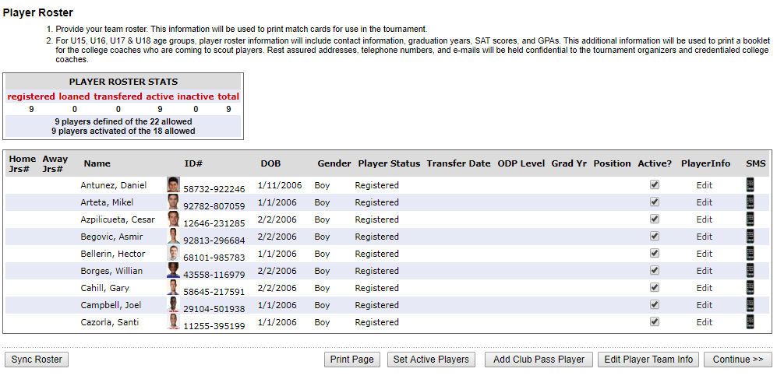
7. Enter the jersey numbers for each player (home and away jersey numbers should be the same).
8. Click Save Changes

